**NLTK**

Named Entity Recognition (NER)

PRESIDENT GEORGE W. BUSH'S ADDRESS BEFORE A JOINT SESSION OF THE CONGRESS ON THE STATE OF THE UNION\n \nJanuary 31, 2006\n\nTHE PRESIDENT: Thank you all.



Mr. Speaker, Vice President Cheney, members of Congress, members of the Supreme Court and diplomatic corps, distinguished guests, and fellow citizens: Today our nation lost a beloved, graceful, courageous woman who called America to its founding ideals and carried on a noble dream.





Tonight we are comforted by the hope of a glad reunion with the husband who was taken so long ago, and we are grateful for the good life of Coretta Scott King.



(Applause.)

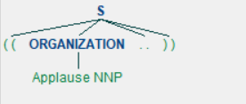

President George W. Bush reacts to applause during his State of the Union Address at the Capitol, Tuesday, Jan.



Chunking

Chunks of noun phrases, basically grouping of nouns, to chunk group information together.

Chunk: {<RB.?>*<VB.?>*<NNP>+<NN>?}

RB.?

RB adverb very, silently,

RBR adverb, comparative better

RBS adverb, superlative best

VB.?

VB verb, base form take

VBD verb, past tense took

VBG verb, gerund/present participle taking

VBN verb, past participle taken

VBP verb, sing. present, non-3d take

VBZ verb, 3rd person sing. present takes

NNP proper noun, singular 'Harrison'

NN noun, singular 'desk'

PRESIDENT GEORGE W. BUSH'S ADDRESS BEFORE A JOINT SESSION OF THE CONGRESS ON THE STATE OF THE UNION\n \nJanuary 31, 2006\n\nTHE PRESIDENT: Thank you all.



Mr. Speaker, Vice President Cheney, members of Congress, members of the Supreme Court and diplomatic corps, distinguished guests, and fellow citizens: Today our nation lost a beloved, graceful, courageous woman who called America to its founding ideals and carried on a noble dream.





Tonight we are comforted by the hope of a glad reunion with the husband who was taken so long ago, and we are grateful for the good life of Coretta Scott King.



(Applause.)

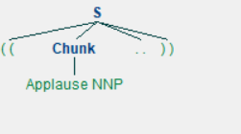

President George W. Bush reacts to applause during his State of the Union Address at the Capitol, Tuesday, Jan.

